**Create a Bucket**

This section will guide you to:

* Create a bucket

This lab has eight subsections, namely:

3.11.1 Selecting S3 from the storage of the AWS service panel

3.11.2 Verifying the button to create a bucket

3.11.3 Providing a bucket name and region

3.11.4 Entering key and value for identification and tracking the bucket

3.11.5 Blocking all the public access

3.11.6 Reviewing all parameters and creating the bucket

3.11.7 Verifying the newly created bucket on the panel of S3

3.11.8 Pushing the files to GitHub repositories

**Step 3.11.1:** Selecting S3 from the storage of the AWS service panel

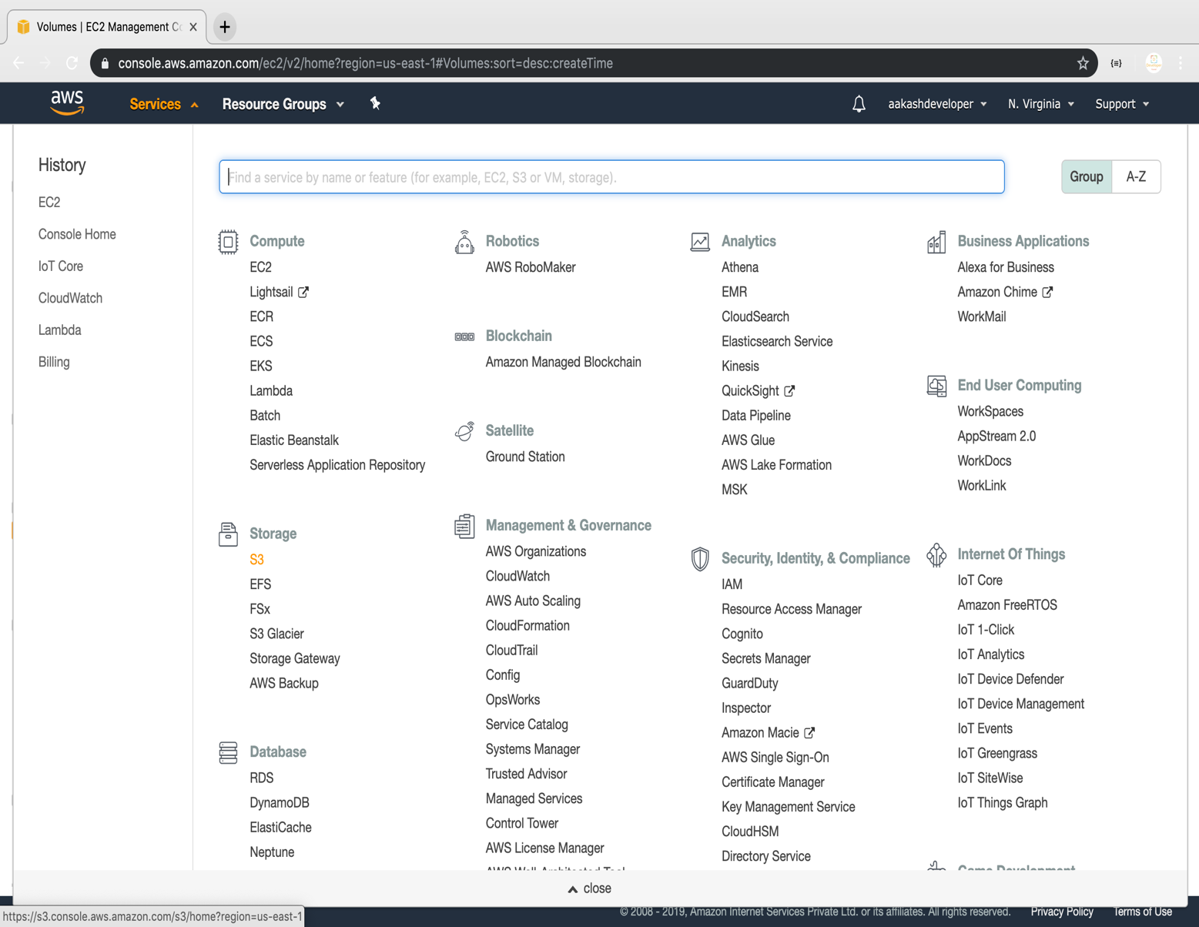

**Step 3.11..2:** Verifying the button to create a bucket

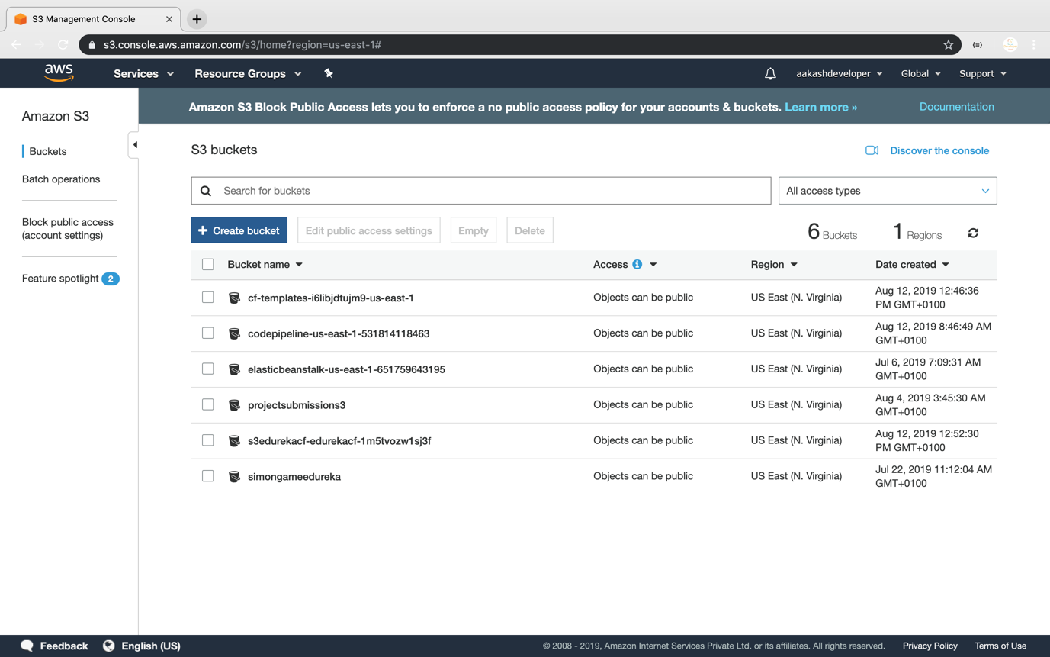

**Step 3.11.3:** Providing a bucket name and region

* Make sure that the bucket name is unique

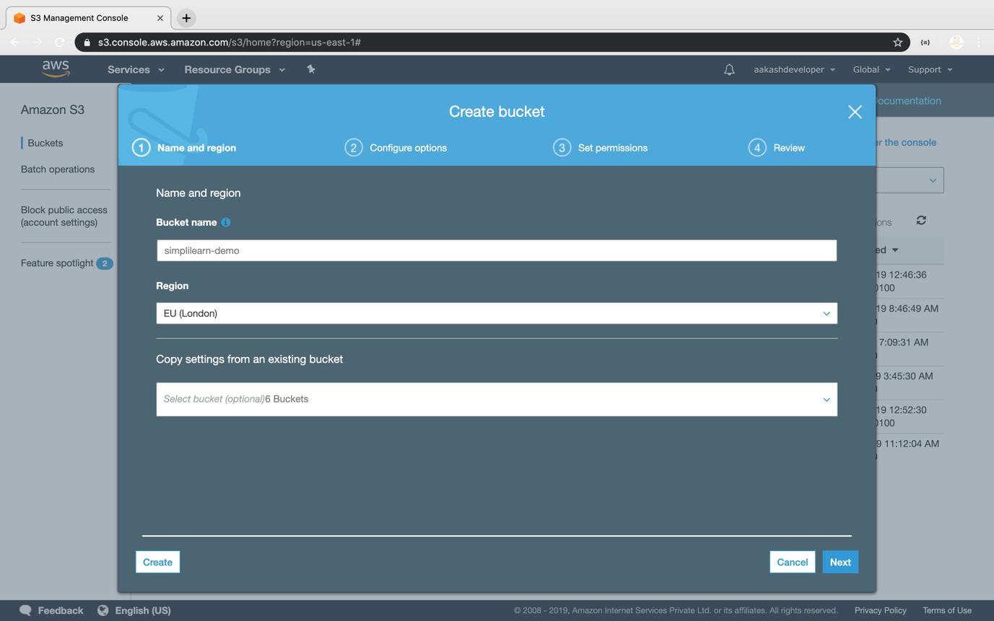

**Step 4.11.4:** Entering key and value for identification and tracking the bucket

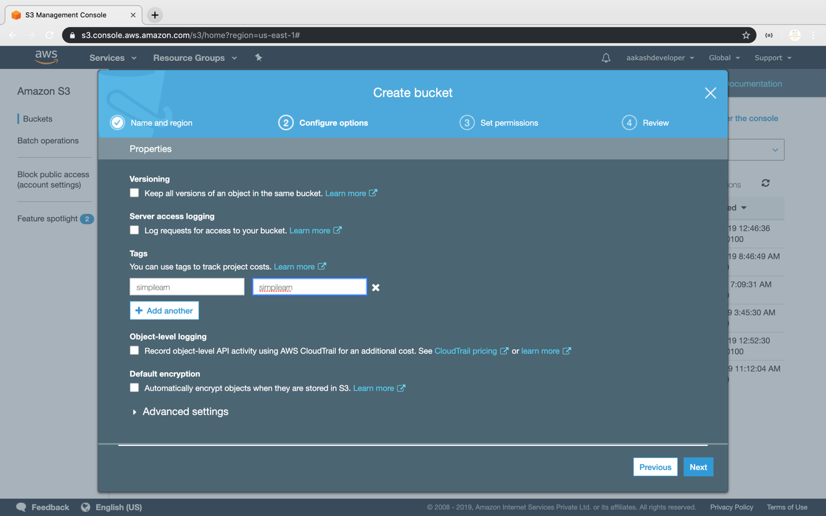

**Step 3.11.5:** Blocking all the public access

* If required, you can configure it later

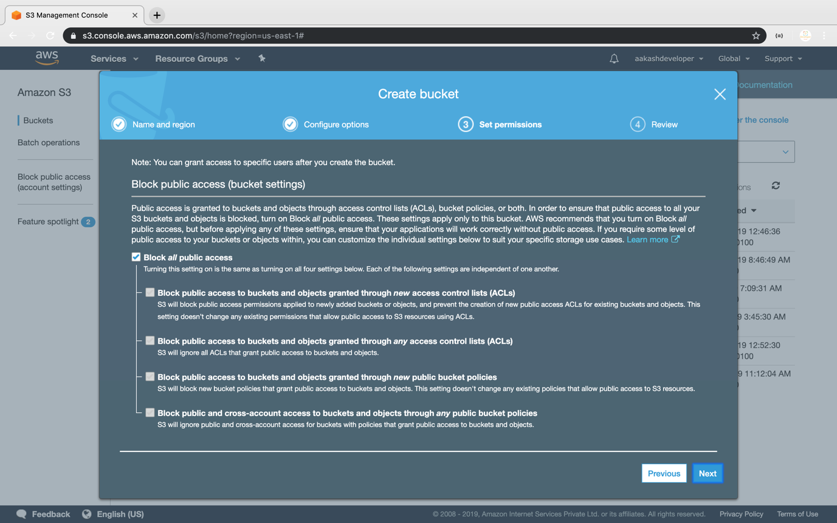

**Step 3.11.6:** Reviewing all parameters and creating the bucket

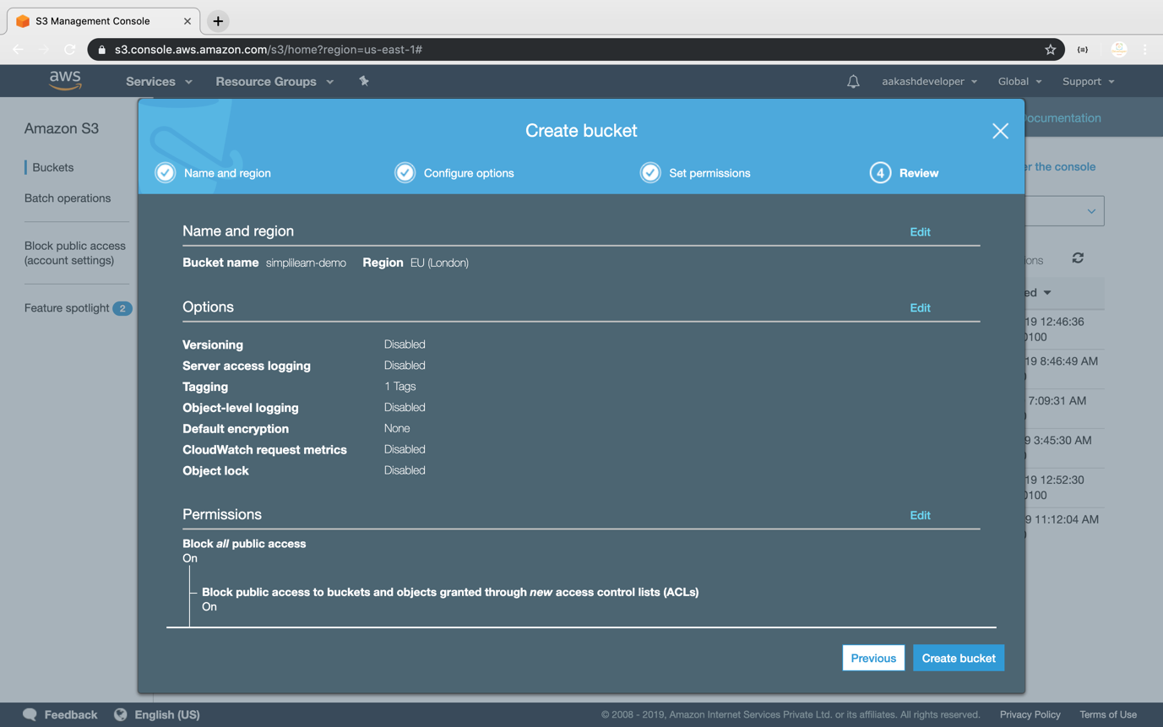

**Step 3.11.7:** Verifying the newly created bucket on the panel of S3

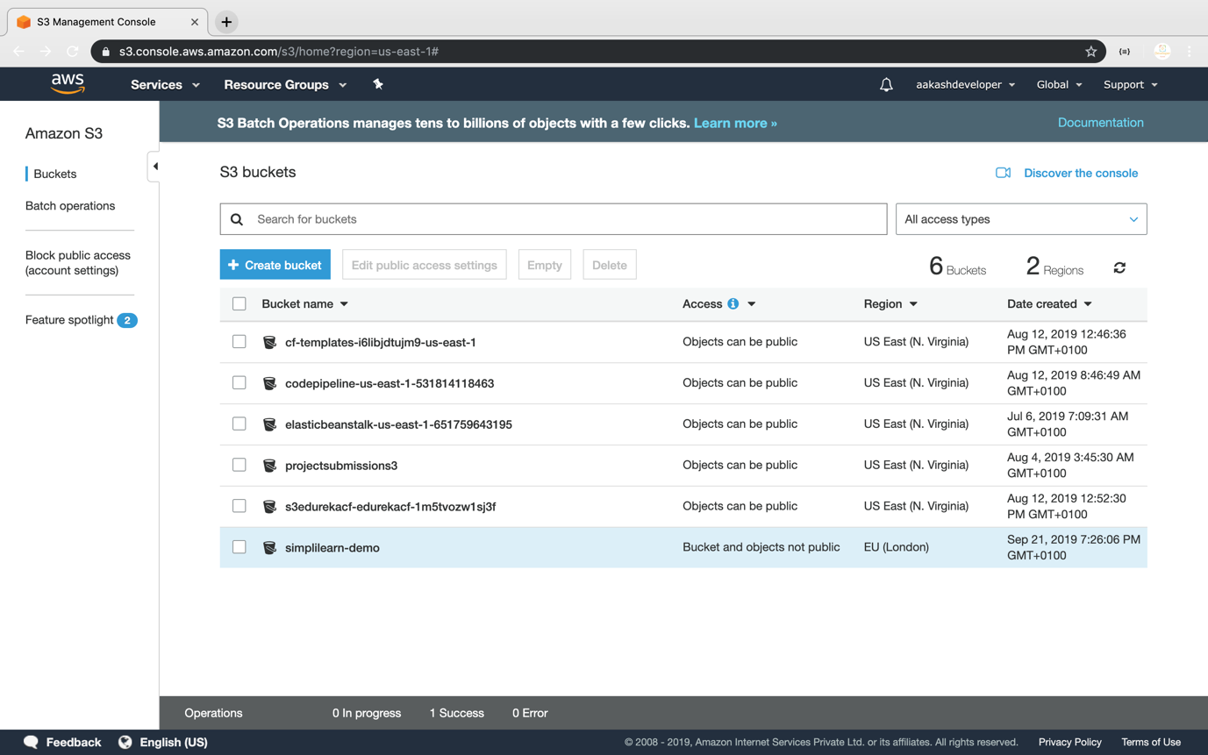

**Step 3.11.8:** Pushing the code to your GitHub repositories

* Open your command prompt and navigate to the folder where you have created your files.

**cd <folder path>**

* Initialize your repository using the following command:

**git init**

* Add all the files to your git repository using the following command:

**git add .**

* Commit the changes using the following command:

**git commit . -m “Changes have been committed.”**

* Push the files to the folder you initially created using the following command:

**git push -u origin master**